Capstone Project Document

KARYWELL

Data Design

|  |  |  |
| --- | --- | --- |
| **KARYWELL** | | |
| **Group Members** | Le Van Quy Hoang | SE90184 |
| Tran Dinh Hoang Huy | SE90201 |
| Nguyen Khac Hoang | SE02564 |
| Kieu Cao Khanh | SE02960 |
| Nguyen Van Quyen | SE02884 |
| Nguyen Thi Hong Nhung | SE02437 |
| **Supervisor** | Mr. Tran Binh Duong | |
| **Project code** | KW | |

**- Hanoi, 12/2015 -**

**Record of Change**

*A-Added M-Modified D-Deleted

|  |  |  |  |  |
| --- | --- | --- | --- | --- |
| **Date** | **Item** | **A, M, D\*** | **Change Description** | **Version** |
| 2015/10/18 | Add new | A |  | V1.0 |
| 2015/12/13 | Modify | M |  | V1.1 |

TABLE OF CONTENTS

1. INTRODUCTION 5

1.1. Purpose 5

1.2. Overview 5

1.3. Definition and Acronyms 5

2. DATABASE 5

2.1. Entity Relationship Diagram 5

2.2. Table Diagram 7

2.2.1. User table 7

2.2.2. Role Table 8

2.2.3. ManageStore Table 8

2.2.4. Stores table 8

2.2.5. BannedHistoryLog table 9

2.2.6. Profile table 9

2.2.7. UserStatus table 10

2.2.8. Stock table 10

2.2.9. Task table 10

2.2.10. TaskType table 11

2.2.11. TaskStatus table 11

2.2.12. GeneralLedger table 11

2.2.13. ConfirmationCodeType table 12

2.2.14. ConfirmationCode table 12

2.2.15. Goods table 12

2.2.16. OrderType table 13

2.2.17. OrderStatus table 13

2.2.18. Order table 14

2.2.19. IssueCategory table 15

2.2.20. IssueType table 15

2.2.21. Issues table 15

2.2.22. OrderIssue table 16

2.2.23. Notification table 16

2.2.24. Province table 16

2.2.25. District table 17

2.2.26. Ward table 17

**1. INTRODUCTION**

## 1.1. Purpose

This document contains database design and its details so it will make the developer get to know specifically about the database system components. Beside it, the tester implement the unit test base on this design document.

## 1.2. Overview

This document is a detail description of the database design of super shipper system. It describes all tables to be created, information stored in each tables, and the relationship between tables.

## 1.3. Definition and Acronyms

| Definition | Description | Note |
| --- | --- | --- |
| P/F Key | Primary/ Foreign key | Use to indicate that a field is a primary or foreign key in table*: P: Primary key,*  *F: foreign key, PK: primary key & foreign key* |
|  |  |  |

# **2. DATABASE**

## 2.1. Entity Relationship Diagram

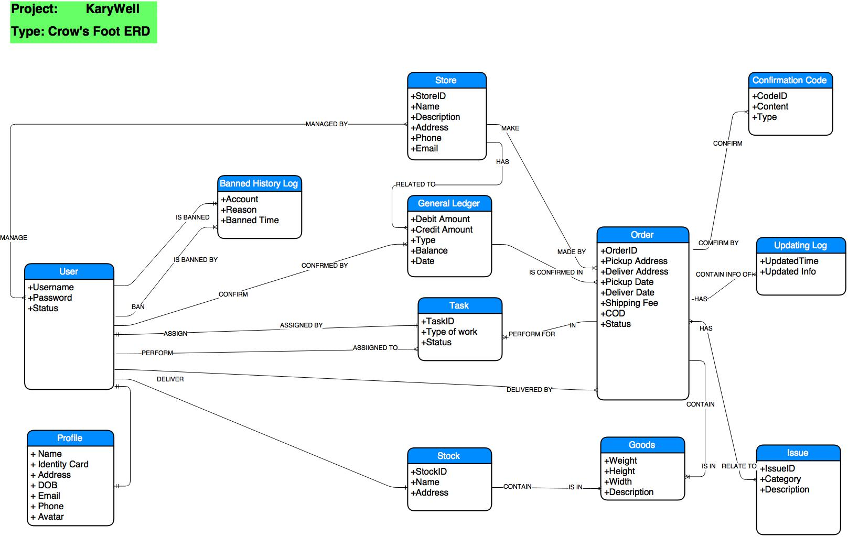

*Figure 1. Crow’s Foot Entity Relationship Diagram*

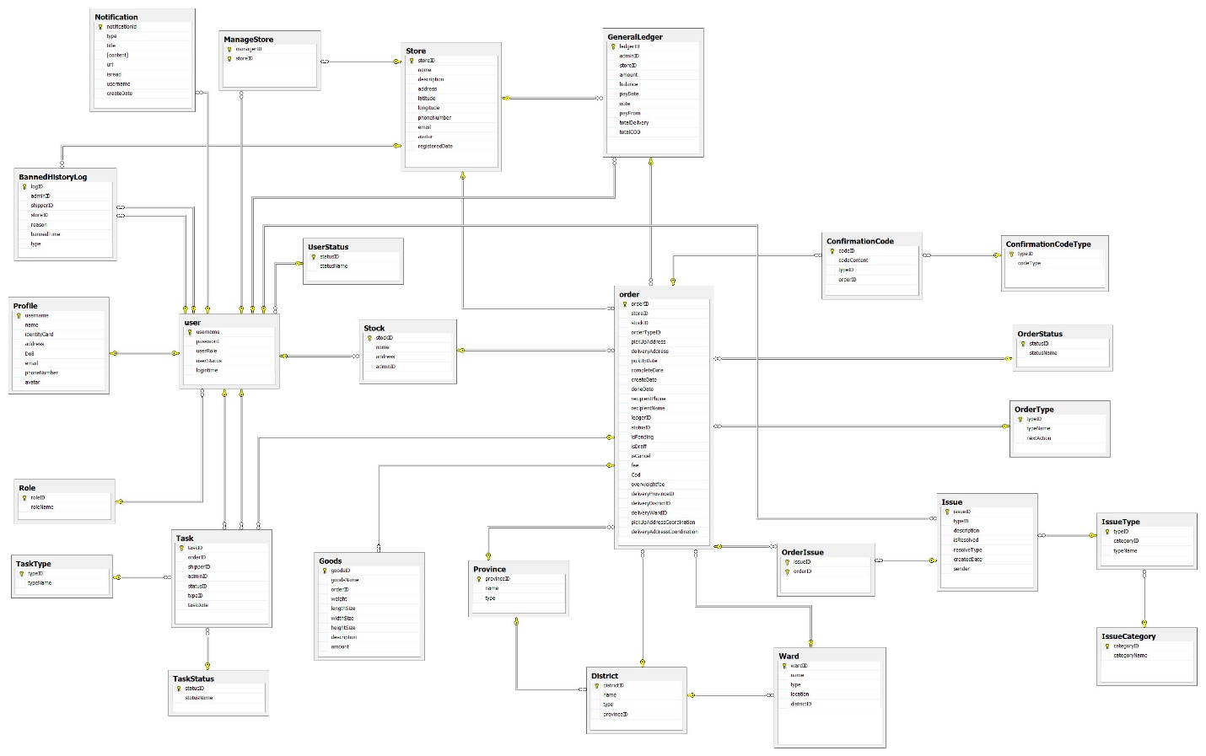

*Figure 2. Entity Relationship Diagram*

|  |  |  |
| --- | --- | --- |
| **No** | **Table** | **Description** |
|  | BannedHistoryLog | Store logs about history of banning account |
|  | ConfimationCode | Store confirmation code for orders and it’s detailed information |
|  | ConfirmationCodeType | Store types of confirmation code |
|  | District | Store district of province |
|  | GeneralLedger | Store transactions with balance of the store and detailed information |
|  | Goods | Store goods and it’s detailed information |
|  | Issue | Store issue’s detailed information |
|  | IssueCategory | Store issue’s category of issue |
|  | IssueType | Store issue’s type of issue |
|  | ManageStore | Store store’s owners and stores which they manage |
|  | Notification | Store detail of all notification |
|  | Order | Store orders and it’s detailed information |
|  | OrderIssue | Store which issue orders have |
|  | OrderStatus | Store statuses of order |
|  | OrderType | Store types of order |
|  | Profile | Store profile of user |
|  | Province | Store provinces in Viet Nam |
|  | Role | Store roles in system |
|  | Stock | Store stocks and it’s detailed information |
|  | Store | Store stores and it’s detailed information |
|  | Task | Store tasks for Shipper with detailed information |
|  | TaskStatus | Store status of task |
|  | TaskType | Store type of task |
|  | User | Store usernames with password, roles and status of username |
|  | UserStatus | Store status of users |
|  | Ward | Store wards of district |

## 2.2. Table Diagram

### 2.2.1. User table

|  |  |  |  |  |  |  |  |  |
| --- | --- | --- | --- | --- | --- | --- | --- | --- |
| **No** | **Field name** | **Type** | **Length** | **Allow Null** | **Unique** | **P/F Key** | **Auto increment** | **Description** |
| 1 | username | VARCHAR | 8 | No | x | P |  | unique username for each user |
| 2 | password | VARCHAR | 255 | No |  |  |  | Password of username in MD5 format |
| 3 | userRole | INT |  | No |  | F |  | roleID of username |
| 4 | userStatus | INT |  | No |  | F |  | statusID of username |
| 5 | logintime | DATE |  | Yes |  |  |  | Last time that user logged in |

### 2.2.2. Role Table

|  |  |  |  |  |  |  |  |  |
| --- | --- | --- | --- | --- | --- | --- | --- | --- |
| **No** | **Field name** | **Type** | **Length** | **Allow Null** | **Unique** | **P/F Key** | **Auto increment** | **Description** |
| 1 | roleID | INT |  | No | x | P | x | Unique id of role |
| 2 | roleName | VARCHAR | 20 | No |  |  |  | Role’s name |

### 2.2.3. ManageStore Table

|  |  |  |  |  |  |  |  |  |
| --- | --- | --- | --- | --- | --- | --- | --- | --- |
| **No** | **Field name** | **Type** | **Length** | **Allow Null** | **Unique** | **P/F Key** | **Auto increment** | **Description** |
| 1 | managerID | VARCHAR | 8 | No | x | PF |  | Unique id of manager |
| 2 | storeID | VARCHAR | 6 | No | x | PF |  | Unique id of store |

### 2.2.4. Stores table

|  |  |  |  |  |  |  |  |  |
| --- | --- | --- | --- | --- | --- | --- | --- | --- |
| **No** | **Field name** | **Type** | **Length** | **Allow Null** | **Unique** | **P/F Key** | **Auto increment** | **Description** |
|  | storeID | VARCHAR | 6 | No | x | P |  | Unique id of store |
|  | name | VARCHAR | 50 | No |  |  |  | Store’s name |
|  | description | TEXT |  | No |  |  |  | Description about store |
|  | address | VARCHAR | 100 | No |  |  |  | Address |
|  | email | VARCHAR | 50 | No | x |  |  | Email |
|  | phoneNumber | VARCHAR | 11 | No | x |  |  | Phone number |
|  | avartar | VARCHAR | 50 | No |  |  |  | Link of avatar of store |
|  | registeredDate | DATE |  | No |  |  |  | Date that store registered |
|  | latitude | VARCHAR | 30 | No |  |  |  | Latitude of address in map |
|  | longitude | VARCHAR | 30 | No |  |  |  | Longitude of address in map |

### 2.2.5. BannedHistoryLog table

|  |  |  |  |  |  |  |  |  |
| --- | --- | --- | --- | --- | --- | --- | --- | --- |
| **No** | **Field name** | **Type** | **Length** | **Allow Null** | **Unique** | **P/F Key** | **Auto increment** | **Description** |
|  | logID | INT |  | No | x | P | x | Unique id of log |
|  | adminID | VARCHAR | 8 | No |  | F |  | Id of admin |
|  | shipperID | VARCHAR | 8 | Yes |  | F |  | ShipperID is banned or unbanned |
|  | storeID | VARCHAR | 6 | Yes |  | F |  | StoreID is banned or unbanned |
|  | reason | TEXT |  | Yes |  |  |  | Reason of ban |
|  | bannedTime | DATE |  | No |  |  |  | Time of ban |
|  | type | VARCHAR | 5 | No |  |  |  | Types of ban: ban or unban |

### 2.2.6. Profile table

|  |  |  |  |  |  |  |  |  |
| --- | --- | --- | --- | --- | --- | --- | --- | --- |
| **No** | **Field name** | **Type** | **Length** | **Allow Null** | **Unique** | **P/F Key** | **Auto increment** | **Description** |
| 1. 1 | username | VARCHAR | 8 | No | x | P |  | Unique username of profile |
| 1. 2 | name | VARCHAR | 50 | No |  |  |  | Full name |
| 1. 3 | identityCard | VARCHAR | 10 | No | x |  |  | Identity Card |
| 1. 4 | address | VARCHAR | 100 | No |  |  |  | Address |
| 1. 5 | DoB | DATE |  | No |  |  |  | Date of birth |
| 1. 6 | email | VARCHAR | 50 | No | x |  |  | Email |
| 1. 7 | avartar | VARCHAR | 50 | No |  |  |  | Link of avatar of user |
|  | phoneNumber | VARCHAR | 11 | No | x |  |  | Phone number |

### 2.2.7. UserStatus table

|  |  |  |  |  |  |  |  |  |
| --- | --- | --- | --- | --- | --- | --- | --- | --- |
| **No** | **Field name** | **Type** | **Length** | **Allow Null** | **Unique** | **P/F Key** | **Auto increment** | **Description** |
| 1. 1 | statusID | INT |  | No | x | P | x | Unique id of status |
| 1. 2 | statusName | VARCHAR | 20 | No |  |  |  | Status of user: ban, unban, active,… |

### 2.2.8. Stock table

|  |  |  |  |  |  |  |  |  |
| --- | --- | --- | --- | --- | --- | --- | --- | --- |
| **No** | **Field name** | **Type** | **Length** | **Allow Null** | **Unique** | **P/F Key** | **Auto increment** | **Description** |
| 1. 1 | stockID | INT |  | No | x | P | x | Unique id of stock |
| 1. 2 | name | VARCHAR | 50 | No |  |  |  | Stock’s name |
| 1. 4 | address | VARCHAR | 100 | No |  |  |  | Address |
| 1. 5 | adminID | VARCHAR | 8 | No |  | F |  | ID of admin who manages the stock |

### 2.2.9. Task table

|  |  |  |  |  |  |  |  |  |
| --- | --- | --- | --- | --- | --- | --- | --- | --- |
| **No** | **Field name** | **Type** | **Length** | **Allow Null** | **Unique** | **P/F Key** | **Auto increment** | **Description** |
| 1. 1 | taskID | INT |  | No | x | P | x | Unique id of stock |
| 1. 3 | statusID | INT |  | No |  | F |  | ID of status of task |
| 1. 4 | adminID | VARCHAR | 8 | No |  | F |  | ID of admin who assigns this task |
|  | shipperID | VARCHAR | 8 | No |  | F |  | ID of shipper who does this task |
|  | orderID | VARCHAR | 8 | No |  | F |  | ID of order |
|  | typeID | INT |  | No |  | F |  | ID of type of task |
|  | taskDate | DATE |  | No |  |  |  | When task is created |

### 2.2.10. TaskType table

|  |  |  |  |  |  |  |  |  |
| --- | --- | --- | --- | --- | --- | --- | --- | --- |
| **No** | **Field name** | **Type** | **Length** | **Allow Null** | **Unique** | **P/F Key** | **Auto increment** | **Description** |
| 1. 1 | typeID | INT |  | No | x | P | x | ID of type |
| 1. 2 | typeName | VARCHAR | 20 | No |  |  |  | Name of type |

### 2.2.11. TaskStatus table

|  |  |  |  |  |  |  |  |  |
| --- | --- | --- | --- | --- | --- | --- | --- | --- |
| **No** | **Field name** | **Type** | **Length** | **Allow Null** | **Unique** | **P/F Key** | **Auto increment** | **Description** |
| 1. 1 | statusID | INT |  | No | x | P | x | ID of status |
| 1. 2 | statusName | VARCHAR | 20 | No |  |  |  | Name of status |

### 2.2.12. GeneralLedger table

|  |  |  |  |  |  |  |  |  |
| --- | --- | --- | --- | --- | --- | --- | --- | --- |
| **No** | **Field name** | **Type** | **Length** | **Allow Null** | **Unique** | **P/F Key** | **Auto increment** | **Description** |
| 1. 1 | ledgerID | INT |  | No | x | P | x | Unique id of ledger |
| 1. 2 | adminID | VARCHAR | 8 | No |  | F |  | Who added this ledger |
| 1. 3 | storeID | VARCHAR | 6 | No |  | F |  | ID of store who sends or receives payment |
| 1. 4 | amount | BIGINT |  | No |  |  |  | Amount of payment |
|  | totalDelivery | BIGINT |  | No |  |  |  | Delivery cost |
|  | totalCOD | BIGINT |  | No |  |  |  | CoD cost |
|  | balance | BIGINT |  | No |  |  |  | Balance after payment |
|  | payDate | DATETIME |  | No |  |  |  | When ledger is posted |
|  | note | TEXT |  | Yes |  |  |  | Note |
|  | payFrom | INT |  | No |  |  |  | Ledger is from store or system |

### 2.2.13. ConfirmationCodeType table

|  |  |  |  |  |  |  |  |  |
| --- | --- | --- | --- | --- | --- | --- | --- | --- |
| **No** | **Field name** | **Type** | **Length** | **Allow Null** | **Unique** | **P/F Key** | **Auto increment** | **Description** |
| 1. 1 | typeID | INT |  | No | x | P | x | Unique id of code type |
| 1. 2 | codeType | VARCHAR | 20 | No |  |  |  | Type of code: Pickup order, delivery order,… |

### 2.2.14. ConfirmationCode table

|  |  |  |  |  |  |  |  |  |
| --- | --- | --- | --- | --- | --- | --- | --- | --- |
| **No** | **Field name** | **Type** | **Length** | **Allow Null** | **Unique** | **P/F Key** | **Auto increment** | **Description** |
| 1. 1 | codeID | INT |  | No | x | P | x | Unique id of confirmation code |
| 1. 2 | typeID | INT |  | No |  | F |  | ID of code type |
| 1. 3 | orderID | VARCHAR | 8 | No |  | F |  | ID of order |
| 1. 4 | codeContent | INT |  | No |  |  |  | Content of code |

### 2.2.15. Goods table

|  |  |  |  |  |  |  |  |  |
| --- | --- | --- | --- | --- | --- | --- | --- | --- |
| **No** | **Field name** | **Type** | **Length** | **Allow Null** | **Unique** | **P/F Key** | **Auto increment** | **Description** |
| 1. 1 | goodsID | INT |  | No | x | P | x | Unique id of goods |
|  | goodsName | VARCHAR | 20 | No |  |  |  | Name of goods |
|  | orderID | VARCHAR | 8 | No |  | F |  | ID of order contains goods |
| 1. 2 | weight | FLOAT |  | No |  | F |  | Weight of goods |
| 1. 3 | lengthSize | FLOAT |  | No |  | F |  | LengthSize of goods |
| 1. 4 | widthSize | FLOAT |  | No |  |  |  | WidthSize of goods |
|  | heightSize | FLOAT |  | No |  |  |  | HeightSize of goods |
|  | description | TEXT |  | No |  |  |  | Description of goods |
|  | amount | INT |  | No |  |  |  | Amount of goods |

### 2.2.16. OrderType table

|  |  |  |  |  |  |  |  |  |
| --- | --- | --- | --- | --- | --- | --- | --- | --- |
| **No** | **Field name** | **Type** | **Length** | **Allow Null** | **Unique** | **P/F Key** | **Auto increment** | **Description** |
| 1. 1 | typeID | INT |  | No | x | P | x | ID of order’s type |
| 1. 2 | typeName | VARCHAR | 20 | No |  |  |  | Name of type: normal, express,… |
|  | nextAction | VARCHAR | 20 | No |  |  |  | Next action of this type |

### 2.2.17. OrderStatus table

|  |  |  |  |  |  |  |  |  |
| --- | --- | --- | --- | --- | --- | --- | --- | --- |
| **No** | **Field name** | **Type** | **Length** | **Allow Null** | **Unique** | **P/F Key** | **Auto increment** | **Description** |
| 1. 1 | statusID | INT |  | No | x | P | x | ID of order’s status |
| 1. 2 | statusName | VARCHAR | 20 | No |  |  |  | Name of order’s status: gathering, delivering,… |

### 2.2.18. Order table

|  |  |  |  |  |  |  |  |  |
| --- | --- | --- | --- | --- | --- | --- | --- | --- |
| **No** | **Field name** | **Type** | **Length** | **Allow Null** | **Unique** | **P/F Key** | **Auto increment** | **Description** |
| 1. 1 | orderID | VARCHAR | 8 | No | x | P |  | Unique id of orders |
| 1. 2 | storeID | VARCHAR | 6 | No |  | F |  | ID of store |
| 1. 3 | stockID | INT |  | No |  | F |  | ID of stock contains order |
| 1. 4 | orderTypeID | INT |  | No |  | F |  | typeID of orders |
|  | pickUpAddress | VARCHAR | 100 | No |  |  |  | Address for picking up order |
|  | deliveryAddress | VARCHAR | 100 | No |  |  |  | Address for delivering up order |
|  | pickUpDate | DATE |  | Yes |  |  |  | Date of picking up order |
|  | completeDate | DATE |  | Yes |  |  |  | Date of delivering order |
|  | createDate | DATE |  | No |  |  |  | Date of creating order |
|  | recipientPhone | VARCHAR | 11 | Yes |  |  |  | Phone of recipient |
|  | recipientName | VARCHAR | 50 | Yes |  |  |  | Recipient’s Name |
|  | ledgerID | INT |  | Yes |  | F |  | ID of ledger of order |
|  | statusID | INT |  | No |  | F |  | ID of order status |
|  | goods | INT |  | No |  | F |  | ID of goods |
|  | fee | BIGINT |  | No |  |  |  | Fee of order |
|  | CoD | BIGINT |  | Yes |  |  |  | Cash on delivery |
|  | Overweightfee | INT |  | Yes |  |  |  | Fee of overweight |
|  | deliveryProvinceID | VARCHAR | 5 | No |  | F |  | ID of province of delivery address |
|  | deliveryDistrictID | VARCHAR | 5 | No |  | F |  | ID of district of delivery address |
|  | deliveryWardID | VARCHAR | 5 | No |  | F |  | ID of ward of delivery address |

### 2.2.19. IssueCategory table

|  |  |  |  |  |  |  |  |  |
| --- | --- | --- | --- | --- | --- | --- | --- | --- |
| **No** | **Field name** | **Type** | **Length** | **Allow Null** | **Unique** | **P/F Key** | **Auto increment** | **Description** |
| 1. 1 | categoryID | INT |  | No | x | P | x | ID of category |
| 1. 2 | categoryName | VARCHAR | 20 | No |  |  |  | Category of issue: Shipper Pending,... |

### 2.2.20. IssueType table

|  |  |  |  |  |  |  |  |  |
| --- | --- | --- | --- | --- | --- | --- | --- | --- |
| **No** | **Field name** | **Type** | **Length** | **Allow Null** | **Unique** | **P/F Key** | **Auto increment** | **Description** |
| 1. 1 | typeID | INT |  | No | x | P | x | ID of type |
| 1. 2 | typeName | VARCHAR | 20 | No |  |  |  | Name of type |
|  | categoryID | INT |  | No |  | F |  | ID of issue category |

### 2.2.21. Issues table

|  |  |  |  |  |  |  |  |  |
| --- | --- | --- | --- | --- | --- | --- | --- | --- |
| **No** | **Field name** | **Type** | **Length** | **Allow Null** | **Unique** | **P/F Key** | **Auto increment** | **Description** |
| 1. 1 | issueID | INT |  | No | x | P | x | ID of issue |
| 1. 2 | typeID | INT |  | No |  | F |  | ID of issue type |
|  | isResolved | BOOLEAN |  | No |  |  |  | Issue is resolved or not |
|  | description | TEXT |  | No |  |  |  | Description |
| 1. r | resolveType | INT |  | Yes |  |  |  | Type of resolve |
|  | createdDate | DATE |  | No |  |  |  | When issue is created |
|  | sender | VARCHAR | 8 | No |  | F |  | Who sent issue |

### 2.2.22. OrderIssue table

|  |  |  |  |  |  |  |  |  |
| --- | --- | --- | --- | --- | --- | --- | --- | --- |
| **No** | **Field name** | **Type** | **Length** | **Allow Null** | **Unique** | **P/F Key** | **Auto increment** | **Description** |
| 1. 1 | issueID | INT |  | No |  | PF |  | ID of issue |
| 1. 2 | orderID | INT |  | No |  | PF |  | ID of order which has issues |

### 2.2.23. Notification table

|  |  |  |  |  |  |  |  |  |
| --- | --- | --- | --- | --- | --- | --- | --- | --- |
| **No** | **Field name** | **Type** | **Length** | **Allow Null** | **Unique** | **P/F Key** | **Auto increment** | **Description** |
| 1. 1 | notificationID | INT |  | No | x | P | x | Unique id of notification |
| 1. 2 | type | VARCHAR | 4 | No |  |  |  | Type of notification: info, error |
| 1. 3 | title | TEXT |  | No |  |  |  | Title of notification |
| 1. 4 | content | TEXT |  | No |  |  |  | Content of notification |
|  | url | TEXT |  | No |  |  |  | URL link to page relate to notification |
|  | isRead | BOOLEAN |  | No |  |  |  | Notification has been read or hasn’t |
|  | username | VARCHAR | 8 | No |  | F |  | Who receive notification |
|  | createDate | DATE |  | Yes |  |  |  | When notification is created |

### 2.2.24. Province table

|  |  |  |  |  |  |  |  |  |
| --- | --- | --- | --- | --- | --- | --- | --- | --- |
| **No** | **Field name** | **Type** | **Length** | **Allow Null** | **Unique** | **P/F Key** | **Auto increment** | **Description** |
| 1. 1 | provinceID | VARCHAR | 5 | No | x | P | x | ID of province |
| 1. 2 | name | VARCHAR | 100 | No |  |  |  | Name of province |
|  | type | VARCHAR | 30 | No |  |  |  | Type of province |

### 2.2.25. District table

|  |  |  |  |  |  |  |  |  |
| --- | --- | --- | --- | --- | --- | --- | --- | --- |
| **No** | **Field name** | **Type** | **Length** | **Allow Null** | **Unique** | **P/F Key** | **Auto increment** | **Description** |
| 1. 1 | districtID | VARCHAR | 5 | No | x | P | x | ID of district |
| 1. 2 | name | VARCHAR | 100 | No |  |  |  | Name of district |
|  | type | VARCHAR | 30 | No |  |  |  | Type of district |
|  | provinceID | VARCHAR | 5 | No |  | F |  | ID of province has district |

### 2.2.26. Ward table

|  |  |  |  |  |  |  |  |  |
| --- | --- | --- | --- | --- | --- | --- | --- | --- |
| **No** | **Field name** | **Type** | **Length** | **Allow Null** | **Unique** | **P/F Key** | **Auto increment** | **Description** |
| 1. 1 | wardID | VARCHAR | 5 | No | x | P | x | ID of ward |
| 1. 2 | name | VARCHAR | 100 | No |  |  |  | Name of ward |
|  | type | VARCHAR | 30 | No |  |  |  | Type of ward |
|  | districtID | VARCHAR | 5 | No |  | F |  | ID of district has ward |
|  | location | VARCHAR | 30 | No |  |  |  | Location of ward in map |